Below are some texts that have been recommended for children in Year 2 from The School Reading List website. Please do not feel that your child has got to read all of them, use this list as a guide.

**Salty Dogs by Matty Long Gorilla by Anthony Brown**

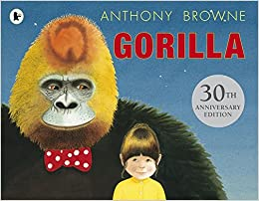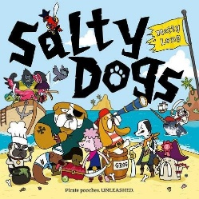

**Don’t look in this Book The Legend of Spud Murphy**

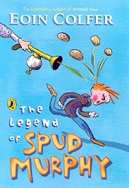**by Samuel Langley-Swain by Eoin Colfer**

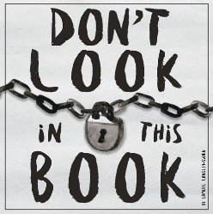

**Dr Xargle’s Book of Earthlets Mr Majeika**

**By Jeanne Willis by Humphrey Carpenter**

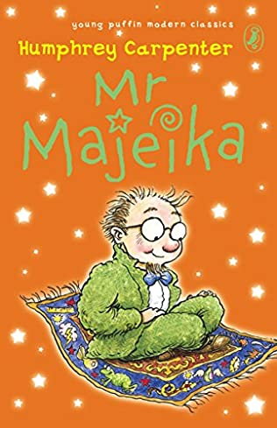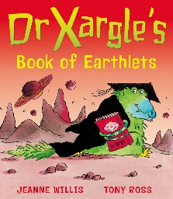

**Jinnie Ghost by Berlie Doherty I Was a Rat! Or, the Scarlette**

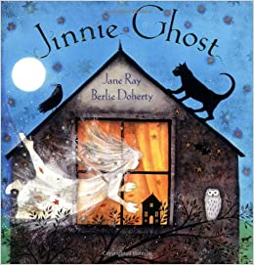  **Slippers by Phillip Pullman**

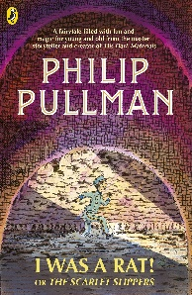

**The Day the Crayons Quit Tuesday by David Wiesner**

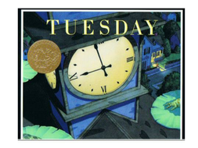 **by Drew Daywalt**

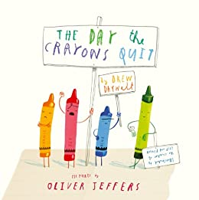

**Beaver Towers by Nigel Hinton A Royal Lullabyhullaballoo**

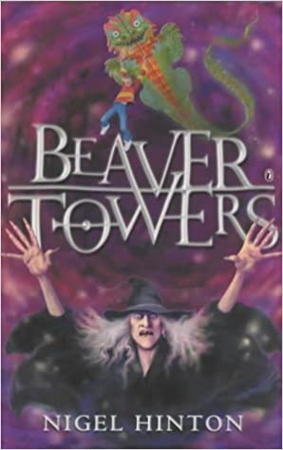 **By Mick Inkpen**

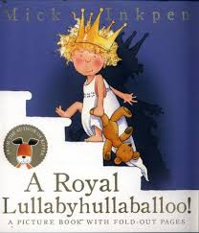

**Triangle by Mac Barnett Fungus the Bogeyman**

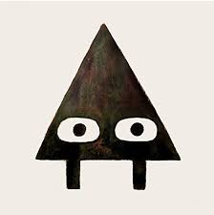 **by Raymond Briggs**

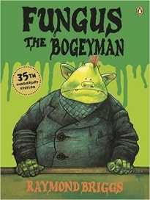

**Mrs Wobble the Waitress by The Dragonsitter by J Lacey**

**Allan Ahlberg**

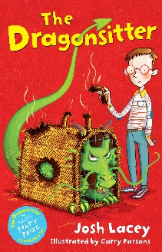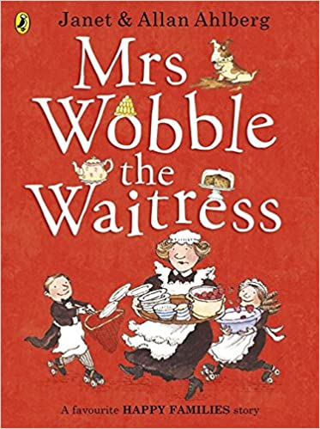

**The Adventures of Captain Underpants The Dunderheads**

**by Dav Pilkey by Paul Fleischman**

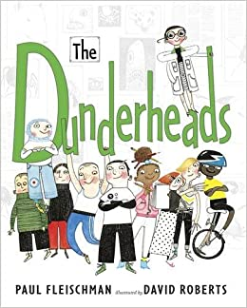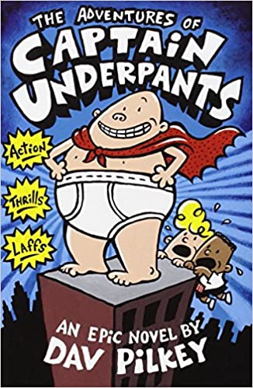

**The Man Whose Mother was a Pirate Mog Time Treasure: Six Stories**

**by Margaret Mahy about Mog the Forgetful Cat by**

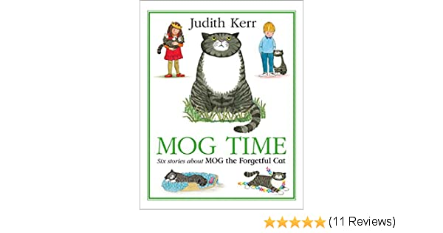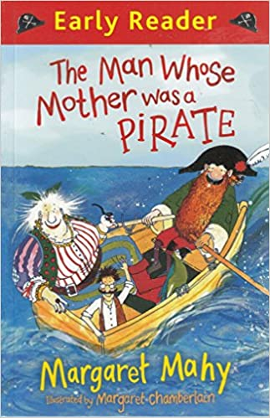 **Judith Kerr**

**Pirate School: Just a Bit of Wind Uncle Gob and the Dread**

**Jeremy Strong Shed by Michael Rosen**

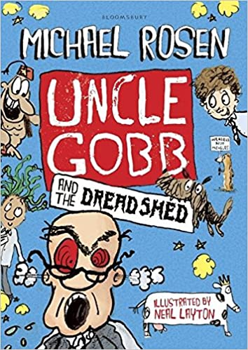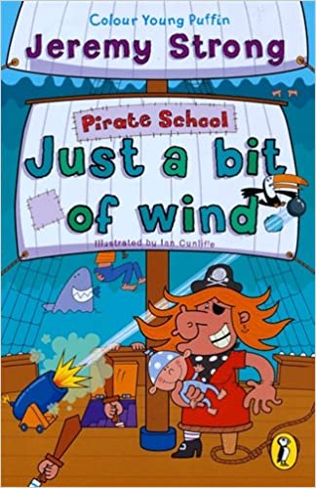

**The Giraffe and the Pelly and Me Mr Wolf’s Pancakes**

**by Roald Dahl by Jan Fearnley**

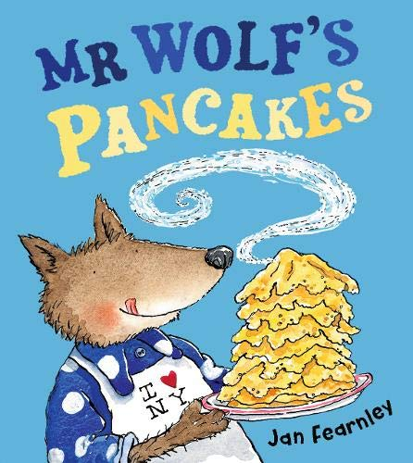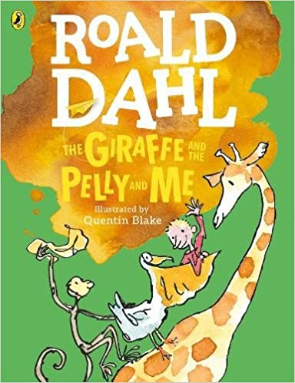

**Gobbolino the Witch’s Cat The Enchanted Wood**

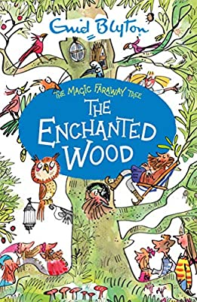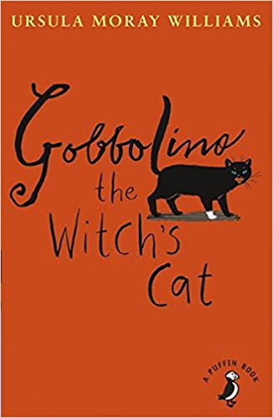 **by Ursula Williams by Enid Blyton**

**Clarice Bean, That’s Me The Story of Babar**

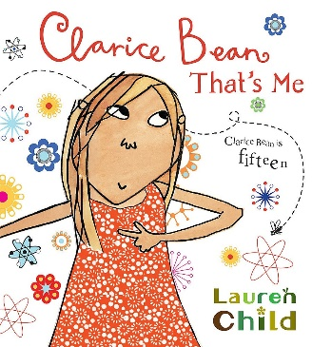 **by Lauren Child by Jean De Brunhoff**

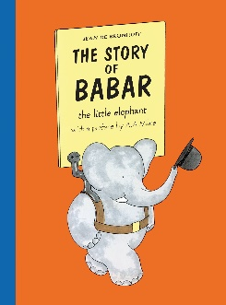

**Nim’s Island by Wendy Orr Fluff the Farting Fish**

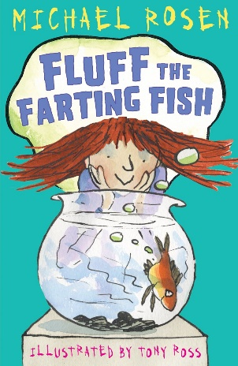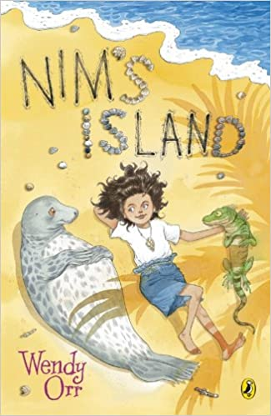 **by Michael Rosen**

**The Tear Thief by Carol Ann Duffy How to Live Forever**

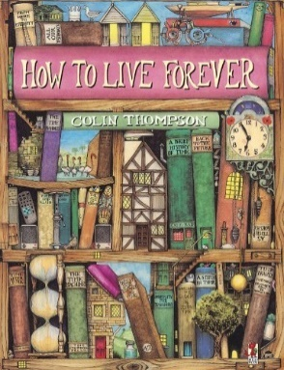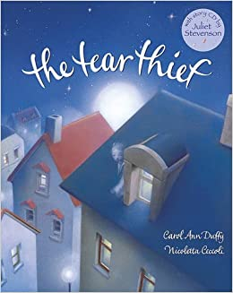 **by Colin Thompson**

**Press Here by Herve Tullet The Penderwicks**

**by Jeanne Birdsall**

